JIM PREPARATORY NURSERY & PRIMARY SCHOOL
IKI-IKI
MOTTO: OUR GOD IS ABLE
TERM TWO ASSEAAMENT EXAMS SET V 2023
PRIMARY TWO
LITERACY 1B
DURATION: 2HRS 15 MIN
NAME: ..................................................................................
STREAM:..............................................................................
INSTRUCTIONS:
1. Read well and answer all questions.
2. You must write well.
3. Write correct spellings.
4. Crossed work may lead to loss of marks.

SECTION A
- What do we call something good to eat or drink?
___________________________________________
- Write one material used to clean the teeth.
___________________________________________
- Which animal roars for protection?
___________________________________________
- Why should a P.2 child do physical body exercises?
___________________________________________
- Mention any one example of common diseases.
___________________________________________
- Give one example of a dangerous object which can cut the body.
____________________________________________
- State one use of pots to people.
____________________________________________
- How many eyes do you have?
____________________________________________
- Write the health activity done after visiting the latrine.
____________________________________________

The diagram below shows a tool used to keep the first aid kit. Use it to answer questions 10 and 11.

- Name the above tool.
____________________________________________
- Mention one item kept in the above tool.
____________________________________________
- How can Tom keep his hands clean?
____________________________________________
- Write any one example of crafts.
____________________________________________
14. What do we call things which do not have life?
____________________________________________
15. Name the local store where dry harvested crops are kept.
____________________________________________
- Why should we clean the animal habitats?
____________________________________________

17. Give any one part of a house.
_____________________________________________
18. Write any one element of weather.
_____________________________________________
19. How is a doctor useful in our community?
_____________________________________________
20. Mention any one source of water.
_____________________________________________
The diagram below shows the parts of a fish. Use it to
answer questions 21 and 22.
K
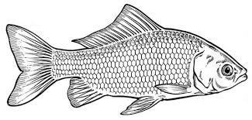
L
M
21. Name part marked M.
____________________________________________
22. How is part marked L useful to a fish?
_____________________________________________
23. Write one thing which makes up the environment.
_____________________________________________
24. Mention one class of food that makes up a balanced diet.
_____________________________________________
25. Why do we need combs when cleaning the body?
_____________________________________________
26. Write one useful thing we get from plants.
_____________________________________________
27. Give one item we use to clean the compound.
_____________________________________________
28. Name one example of food we eat before cooking.
_____________________________________________
29. What is wind?
_____________________________________________
30. Write any one example of vectors.
_____________________________________________
31. How do people get food from lakes?
_____________________________________________
32. Name this tool used for proper disposal of rubbish.
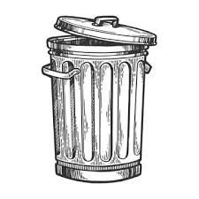_________________________________
33. What do we call the meat of a cow?
_____________________________________________
34. How can mothers care for the babies at home ?
____________________________________________
35. Name the part of the body used for chewing food.
____________________________________________36. Why do babies need vitamins in their diet?
____________________________________________
37. State one characteristic of living things.
_____________________________________________
38. Write any one useful thing got from birds.
_____________________________________________
39. Name one place where wild animals live.
_____________________________________________
40. In the space below, draw a granary.
granary

SECTION B
41. (a) Write any two examples of clothes.
(i)_________________________________________
(ii) _________________________________________
(b) How do we keep our clothes clean?
__________________________________________
(c) Why do we iron our clothes?
___________________________________________
42. (a) State any two ways of preserving food.
(i)_________________________________________
(ii) _________________________________________
(b) Write any two diseases got through eating dirty food.
(i)_________________________________________
(ii) _________________________________________
43. a) How are these materials useful when carrying out
personal hygiene?
- 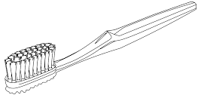_______________________
- 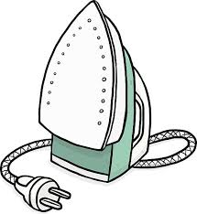____________________________
b) Apart from the above materials, mention any other two
items used to keep the body clean.
(i)_________________________________________
(ii) _________________________________________
44. Match animals in A to their way of movements in B.
A B
- snake by swimming
- fish by gliding
- frog by walking
- man by jumping
Correct order
- snake ___________________
- fish ___________________
- frog ___________________
- man ___________________
45. (a) How do we keep our hair clean?
(i)_________________________________________
(ii) _________________________________________
(b) Mention the parasites Peter can get if he does not keep
his hair clean.
__________________________________________
(c) Why do we keep our hair clean?
___________________________________________
46. (a) What do we call animals kept at home?
___________________________________________
(b) Mention any two examples of animals kept at home.
- _______________________________________
- _______________________________________
(c) Why do people keep domestic animals like cows?
__________________________________________
47. (a) Write any two containers used to store food.
(i) ________________________________________
(ii) _________________________________________
- State two uses of water at home.
- _______________________________________
- _______________________________________
48. The diagram below shows the parts of a plant.
Study it carefully and use it to answer the given
questions.
A
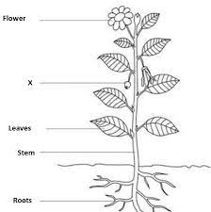
D
C
B
- Name parts marked;
A:_________________ B:________________ C:__________________

(b) How is part marked D useful to people?
_________________________________________
49. a) Name any two examples of insects which sting people.
(i) _______________________________________
(ii) _______________________________________
b) Write two things people get from bees.
(i)_________________________________________ (ii)_________________________________________
50. (a) Mention any two items used in the kitchen.
(i)_______________________________ __________ (ii)_________________________________________

- How can we keep the kitchen clean at home?
_________________________________________
- Why do we keep the kitchen clean at home?
_________________________________________
51. (a) Write the two types of seasons.
(i)__________________________________________ (ii)_________________________________________
(b) State the activities that are done in the following
seasons.
(i) dry season; ________________________________ (ii) wet season; ________________________________

52. The diagram below shows the garden tool used by
farmers. Use it to answer the given questions.
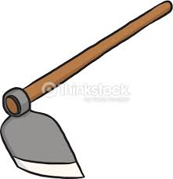
- Name the garden tool above.
__________________________________________
(b) How is the above garden tool useful to a farmer?
__________________________________________
(c) Apart from the above garden tool, mention any two other
examples of garden tools.
(i)_________________________________________(ii)_________________________________________
53. (a) What do we call the sudden happening that causes harm
to the body?
___________________________________________
(b) Write any two examples of common accidents.
(i) __________________________________________
(ii) __________________________________________
(c) State one danger of accidents to people.
____________________________________________
54. (a) Draw these examples of utensils.
plates | spoons

- How do we keep the above utensils clean?
_________________________________________
- Write any one item used to clean the utensils above.
_____________________________________
55. (a) Mention any two examples of fruits eaten at school.
(i)__________________________________________
(ii)__________________________________________

(b) Give two ways of caring for plants in the garden.
(i)______________ ____________________________
(ii)___________ _______________________________
END

